Tyler Butler Lab 4 Assignment

**Software Sales**

A software company sells a package that retails for $99. Quantity discounts are given according to the

following table:

Quantity Discount

10–19 20%

20–49 30%

50–99 40%

100 or more 50%

Write a program that asks the user to enter the number of packages purchased. The pro- gram should

then display the amount of the discount (if any) and the total amount of the purchase after the

discount.

**ANSWER:**

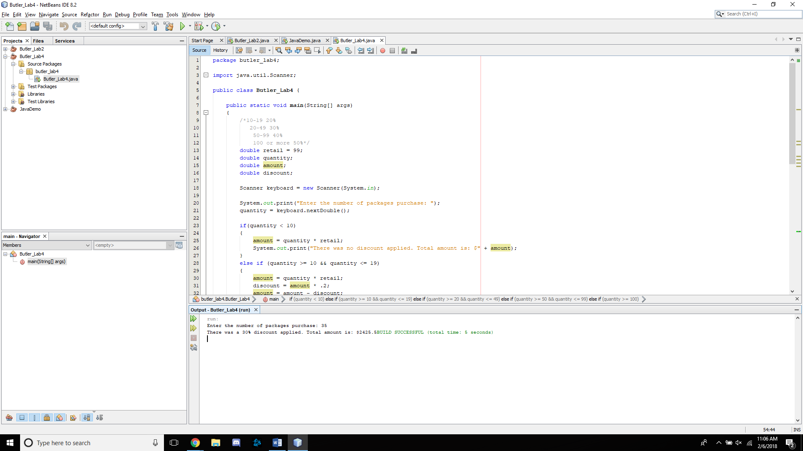

**Fat Gram Calculator**

Write a program that asks the user to enter the number of calories and fat grams in a food item. The

program should display the percentage of the calories that come from fat. One gram of fat has 9

calories; therefore:

Calories from fat = 5 Fat grams * 9

The percentage of calories from fat can be calculated as follows:

Calories from fat 4 ÷ Total calories

If the calories from fat are less than 30 percent of the total calories of the food, it should also display a

message indicating the food is low in fat.

ANSWER:

